EMCH361 Mechanical Engineering Laboratory I, Spring 2022

Laboratory 3
Strain Measurements

Brown, Ryan
Section 004
Email: rb23@email.sc.edu
03/17/2022
Department of Mechanical Engineering
University of South Carolina
Columbia, SC 29208

Abstract

introduction

Strain is a very important measurement in the regards of material properties. Strain is the change in length of the specimen over the original length when a load is applied. This delta in length tells engineers and scientists a lot about a material. If a material can withstand a large load with little deformation, in a situation where this is desired such as girders in a bridge, then that material would be chosen over a more elastic material. The unit of strain is dimensionless, this is due to being a proportion of change in length over original length, the units will cancel.
In this lab, strain will be measured using a strain gauge. A strain gauge is an electronic sensor that can detect changes in length along the direction it is applied. Using this analog output, paired with a Data Acquisition System, a physical quantity can be obtained based on the force applied. This physical quantity will be displayed on a software known as LABView, Laboratory Virtual Instrument Engineering Workbench. The software will display the strain in micro strain, and the force in pounds. After finding those two measurements, the Young’s Modulus can be calculated using a graph with stress being the independent variable and strain being the dependent.
Another approach would be to use a statistical evaluation of stress versus strain using Equation 1. Equation 1 can be used to directly calculate the Young’s Modulus of the specimen. Equation 1 is:
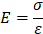
(1)
This relationship between stress and strain means that the Modulus of elasticity, Young’s Modulus, can be easily calculated, given that the units are correct. Stress is described as force over and area, or Pascals. With the force being given in pounds, it first must be converted into newtons using a constant to multiply by. Calculating moment and the inertia of the specimen will allow the scientist to then calculate the stress. The equations follow respectively:

(2)

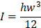
(3)
Stress is calculate using the formula:

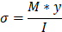
(4)
After calculating stress and strain, the Young’s Modulus can be found by either looking at the slope of the graph, or by using equation (1). The specimen can then be identified based on the young’s modulus.

instruments

The main two instruments use din this lab are the strain gauge and LABView. The strain gauge is essential to the experiment, as it is the device that will tell the user by how much the material deforms. A strain gauge is an analog sensor that reacts to its environment. It is comprised of a long, thin wire that is coiled many times to increase the overall length. Once a force is applied to the beam the material will deform and the top of the cantilever beam will experience elongation. The strain gauge being adhered to the top of the beam, will elongate with the beam. Since the wires are coiled up in the strain gauge the overall length change is much greater. When a voltage is applied to the unstrained wire it will operate at a certain resistance. When the object elongates in the correct direction, the wires will elongate, causing a change in resistivity of the strain gauge. When paired with a Wheatstone bridge and an amplifier the change in resistivity can be detected and ran into a DAQ, Data Acquisition System.

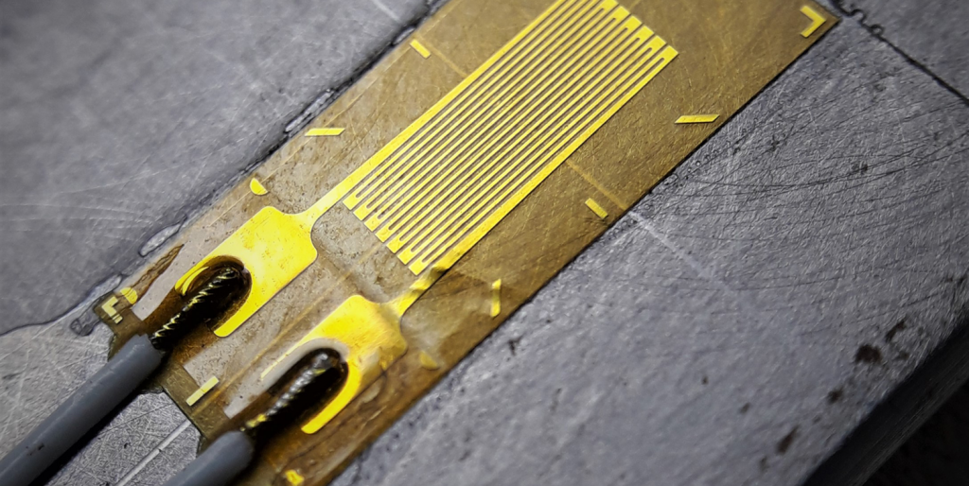
Figure 1: Close up of strain gauge

When the Strain Gauge is paired with LABView, a digital output for force and strain can be given. A block diagram is formed to display these results on the front panel. LABView is a software that allows the user to code, but graphically. Functions and structures are represented pictorially and make it easy to visualize a physical version of your developed code. This code takes an input from the analog to digital converter and outputs a physical quantity based on known constants.

procedures

The lab would begin by fixing one side of the cantilever beam in the brace so that only one side can move. Next the force applicator is set up on the free end of the beam and the strain gauge is properly adhered to the fixed end. For the best results both devices should be applied at the respective extremes of the bar to produce the most accurate results. As the most strain happens at the base of the fixed side. Both devices are then connected to the DAQ, and then to the computer so that LABView can convert to a physical quantity.
Now that everything is set up, the run button on the front panel should be clicked, and the force applicator should be set so that LABView reads one pound. The stop button is pressed, and the strain displayed is recorded as well as the exact force applied. This process is repeated for values of 1.2, 1.4, 1.6, 1.8, and 2.0 pounds.
Following recording of the data, conversions must be made. First pounds must be converted into newtons so that the moment can be found. The moment is found and recorded for each set. The stress can be found using equation (4) and is then recorded. The stress versus strain diagram can now be produced.

Numerical analysis and results

Discussion and Conclusion

acknowledgments

REFERENCES
[1]

